

Mini Project Report
On
Personal Expense Tracker Site

SUBMITTED BY: SUBMITTEDTO:
Ayush Thakur Mr. Shivam Ojha
UID: 26MCI10311 Assistant Professor
CLASS: MCA (AI&ML)
Course Code: 26CAH-614
SECTION: 26MAM5(B)

Table ofContent

S.No. | Name | Page no.
Chapter 1 | Introduction/Background | 4
Chapter 2 | Objective/ Technologies Used | 4
Chapter 3 | Technologies Used | 4
Chapter 4 | Requirements and System Design | 5-6
Chapter 5 | Source Code & Output | 7-12
Chapter 6 | Functionalities | 13
Chapter 7 | Conclusion/Future Work/ Learning Out comes | 14

DECLARATION

I hereby declare that the mini project report entitled "PERSONAL EXPENSE TRACKER SITE" is my original work, completed as part of the academic requirements of the Master of Computer Applications (MCA AI & ML) program at Chandigarh University. This project has been developed to help users manage, record, track, and analyze their daily expenses. It provides an easy-to-use platform for maintaining financial records, monitoring spending habits, and managing personal budgets. I further declare that this project has not been submitted previously to any other university or institution for the award of any degree or diploma.
Submitted By: Ayush Thakur(26MCI10311)
Course:MCA(AI&ML)
Student Signature: __________
Date: __________

ACKNOWLEDGEMENT
I would like to express my sincere gratitude to Chandigarh University for providing me with the opportunity to complete my mini project entitled "PERSONAL EXPENSE TRACKER SITE". I am especially thankful to my project guide, Mr. Shivam Ojha, Assistant Professor, for his valuable guidance, support, and encouragement throughout the development of this project. I would also like to thank the Department of Computer Applications for providing the necessary resources and knowledge to complete this project successfully. Finally, I would like to thank my friends and family for their continuous support and motivation.
Ayush Thakur(26MCI10311)
MCA (AI & ML)

CHAPTER 1: INTRODUCTION / BACKGROUND

1.1 Introduction
The Personal Expense Tracker Site is a web-based application designed to help users manage and track their daily expenses easily. It allows users to record their income and expenses, categorize transactions, and monitor their spending habits. The main purpose of this project is to help users understand where their money is being spent and manage their monthly budget effectively. This website provides a simple and user-friendly interface where users can add, update, delete, and view their financial records.

1.2 Background of the Project
Nowadays, managing personal finances is very important. Many people find it difficult to remember their daily expenses and maintain financial records manually. Traditional methods, such as notebooks and Excel sheets, require more time and effort. To solve this problem, the Personal Expense Tracker Site provides a digital solution for recording and managing expenses. This project helps users maintain their financial information in one place and makes expense management easier.

1.3 Problem Statement
Managing daily expenses manually can create several problems:
- Difficulty in tracking daily expenses.
- Lack of proper monthly budget management.
- Difficulty in identifying unnecessary spending.
- Risk of losing manually maintained records.
- Time-consuming calculations of total expenses.
The Personal Expense Tracker Site solves these problems by providing a simple online platform for managing financial records.

1.4 Purpose of the Project
The main purpose of this project is to develop a simple website that helps users manage their personal expenses. The project aims to:
- Record daily income and expenses.
- Categorize expenses.
- Calculate total income and expenses.
- Display available balance.
- Monitor monthly spending.
- Generate expense summaries.

1.5 Scope of the Project
The scope of the Personal Expense Tracker Site includes:
- Users can add their daily expenses.
- Users can view their transaction history.
- Users can edit and delete expense records.
- Users can check their total expenses.
- Users can calculate their remaining balance.
- Users can manage their monthly budget.
In the future, this project can be improved by adding AI-based spending predictions, graphical reports, and mobile application support.

1.6 Overview of the System
The Personal Expense Tracker Site works through three main parts:
- Frontend: Provides the user interface using HTML, CSS, and JavaScript.
- Backend: Handles application logic and processes user requests using Python.
- Database: Stores user details, income records, and expense information.
The frontend communicates with the backend, and the backend manages the data stored in the database.

1.7 Advantages of the Project
- Easy to use and understand.
- Saves time compared to manual record keeping.
- Helps control unnecessary expenses.
- Provides accurate expense calculations.
- Maintains financial records in one place.
- Helps users plan their monthly budget.

1.8 Conclusion
The Personal Expense Tracker Site is a useful web-based application for managing personal finances. It helps users record income and expenses, calculate their balance, and understand their spending habits. This project provides a simple and effective solution for daily expense management.

CHAPTER 2: OBJECTIVES AND TECHNOLOGIES USED

2.1 Objectives of the Project
The main objective of the Personal Expense Tracker Site is to develop a simple and user-friendly web application that helps users manage their daily income and expenses. The major objectives are:
- Expense Management: To record and manage daily expenses easily.
- Income Management: To maintain records of different income sources.
- Budget Planning: To help users plan and manage their monthly budgets.
- Expense Categorization: To divide expenses into categories such as food, shopping, travel, education, and bills.
- Balance Calculation: To calculate the remaining balance automatically.
- Transaction History: To maintain records of previous income and expenses.
- Time Saving: To reduce manual calculations and paperwork.
- Financial Awareness: To help users understand their spending habits.

2.2 Main Objectives
- Create a simple and attractive website.
- Provide an easy way to add income and expenses.
- Display total income, total expenses, and remaining balance.
- Allow users to update and delete transactions.
- Store financial records securely in a database.
- Provide a clear overview of personal financial activities.

2.3 Technologies Used
The Personal Expense Tracker Site uses the following technologies:
1. HTML (Hyper Text Markup Language)
HTML is used to create the basic structure of the website. It defines elements such as headings, forms, buttons, tables, and input fields.
2. CSS (Cascading Style Sheets)
CSS is used to design and style the website. It controls colours, fonts, layouts, spacing, and the overall appearance of web pages.
3. JavaScript
JavaScript is used to make the website interactive. It helps perform actions such as form validation, button interactions, and dynamic updates.
4. Python
Python is used as the backend programming language. It handles application logic, processes user requests, and performs expense calculations.
5. Flask
Flask is a lightweight Python web framework used to connect the frontend with the backend and manage website routes.
6. SQ Lite Database
SQ Lite is used to store transaction details, income records, expense categories, and other application data.

2.4 Hardware Requirements
Component | Minimum Requirement
Processor | Intel Core i3 or equivalent
RAM | 4 GB
Hard Disk | 500 MB free space
Computer | Desktop or Laptop
Internet | Required for online access

2.5 Software Requirements
Software | Purpose
Windows 10/11 | Operating System
Python 3.x | Backend Programming
Flask | Web Framework
HTML | Website Structure
CSS | Website Design
JavaScript | Website Interactivity
SQ Lite | Database Management
VS Code | Code Editor
Google Chrome | Website Testing

2.6 Working of Technologies
The website works with the help of three main components:
Frontend
HTML + CSS + JavaScript
User interface and website design
Backend
Python + Flask
Application logic and calculations
Database
SQ Lite
Stores income and expense records

2.7 Benefits of Technologies Used
- HTML provides a structured website.
- CSS makes the website attractive.
- JavaScript improves user interaction.
- Python makes calculations easier.
- Flask connects frontend and backend.
- SQ Lite stores records efficiently.

2.8 Conclusion
This chapter explains the objectives and technologies used in the development of the Personal Expense Tracker Site. HTML, CSS, JavaScript, Python, Flask, and SQLite work together to create a simple and effective expense management application. These technologies make the website easy to develop, maintain, and use.

CHAPTER 3: TECHNOLOGIES USED

3.1 Introduction
The Personal Expense Tracker Site is developed using different web development technologies and programming tools. These technologies work together to create a user-friendly website that allows users to record, manage, and track their daily income and expenses. The project uses HTML, CSS, and JavaScript for frontend development, Python and Flask for backend development, and SQ Lite for database management.

3.2 Frontend Technologies
1. HTML (Hyper Text Markup Language)
HTML is the standard markup language used to create the structure of a website.
Uses in this project:
- Creating the homepage.
- Designing income and expense forms.
- Creating navigation menus.
- Displaying transaction tables.
- Adding buttons and input fields.
2. CSS (Cascading Style Sheets)
CSS is used to improve the appearance and design of the website.
Uses in this project:
- Adding background colours.
- Designing buttons and forms.
- Managing page layouts.
- Setting fonts and text sizes.
- Making the website attractive and responsive.
3. JavaScript
JavaScript is a programming language used to make websites interactive and dynamic.
Uses in this project:
- Validating user input.
- Handling button clicks.
- Displaying confirmation messages.
- Updating website elements dynamically.
- Improving user interaction.

3.3 Backend Technologies
1. Python
Python is a high-level programming language used for backend development.
Uses in this project:
- Processing income and expense records.
- Calculating total income.
- Calculating total expenses.
- Calculating available balance.
- Managing application functionality.
2. Flask Framework
Flask is a lightweight Python web framework used to develop web applications.
Uses in this project:
- Connecting frontend and backend.
- Managing website routes.
- Processing form submissions.
- Handling user requests.
- Communicating with the SQLite database.

3.4 Database Technology
SQLite Database
SQLite is a lightweight relational database used to store and manage application data.
Uses in this project:
- Storing income records.
- Storing expense records.
- Maintaining transaction history.
- Storing transaction dates.
- Managing expense categories.
Example of database table:
ID | Category | Amount | Type
1 | Food | ₹500 | Expense
2 | Salary | ₹15,000 | Income
3 | Shopping | ₹1,000 | Expense
4 | Travel | ₹300 | Expense

3.5 Development Tools
Tool | Purpose
Visual Studio Code | Writing and editing code
Python IDLE | Running Python programs
Google Chrome | Testing the website
Flask | Developing the web application
SQLite | Storing application data
Command Prompt | Running the application

3.6 System Architecture
The Personal Expense Tracker Site follows a simple three-tier architecture.
Presentation Layer

HTML + CSS + JavaScript
User interface
Application Layer

Python + Flask
Business logic and calculations
Database Layer

SQLite
Data storage and management

3.7 Working Process of the Technologies
- The user opens the Personal Expense Tracker website.
- The frontend displays forms and dashboard information.
- The user enters income or expense details.
- Flask receives the submitted information.
- Python processes the information and performs calculations.
- SQLite stores the transaction details.
- The website displays updated financial information.

3.8 Advantages of Technologies Used
- Easy to develop and maintain.
- Simple and user-friendly interface.
- Fast data processing.
- Efficient database management.
- Automatic expense calculations.
- Low development cost.
- Suitable for small web applications.

3.9 Conclusion
This chapter describes the technologies and development tools used to build the Personal Expense Tracker Site. HTML, CSS, and JavaScript are used for frontend development, while Python and Flask handle backend operations. SQLite is used to store and manage financial records. All these technologies work together to provide an effective personal expense management system.

CHAPTER 4: REQUIREMENTS AND SYSTEM DESIGN

4.1 Introduction
The Personal Expense Tracker Site is a web-based application developed to help users manage their daily income and expenses. This chapter explains the hardware requirements, software requirements, system design, architecture, and database structure of the project. The system provides an easy way to add, view, update, and delete financial transactions. It also calculates total income, total expenses, and the remaining balance.

4.2 Hardware Requirements
Hardware requirements describe the physical devices needed to develop and run the project.
Hardware | Minimum Requirements
Processor | Intel Core i3 or equivalent
RAM | 4 GB
Hard Disk | 500 MB free space
System | Desktop or Laptop
Keyboard | Standard Keyboard
Mouse | Standard Mouse
Display | Standard Monitor

4.3 Software Requirements
Software requirements describe the applications and programming technologies required to develop the project.
Software | Purpose
Windows 10/11 | Operating System
Python 3.x | Backend Programming
Flask | Web Framework
HTML | Webpage Structure
CSS | Website Design
JavaScript | Website Interactivity
SQLite | Database Management
VS Code | Code Editor
Google Chrome | Website Testing

4.4 Functional Requirements
Functional requirements describe the main operations performed by the system.
- Add Transaction: Users can add income and expense details.
- View Transaction: Users can view their previous transactions.
- Update Transaction: Users can edit existing transaction details.
- Delete Transaction: Users can delete unwanted records.
- Calculate Income: The system calculates total income automatically.
- Calculate Expenses: The system calculates total expenses automatically.
- Calculate Balance: The system displays the remaining balance.
- Expense Categories: Users can organize expenses into different categories.

4.5 Non-Functional Requirements
Non-functional requirements describe the quality and performance of the application.
- Usability: The website should be easy to use.
- Performance: The application should respond quickly.
- Reliability: The system should store records correctly.
- Security: Financial records should be protected from unauthorized access.
- Maintainability: The source code should be easy to update.
- Compatibility: The website should work on commonly used web browsers.

4.6 System Architecture
The Personal Expense Tracker Site follows a three-tier architecture.
1. Frontend Layer
HTML + CSS + JavaScript
Displays forms, buttons and dashboard
Request and response
2. Backend Layer
Python + Flask
Processes requests and calculates expenses
Database operations
3. Database Layer
SQLite
Stores income and expense records

4.7 System Flowchart
The following flowchart explains how the Personal Expense Tracker Site works.
Working steps:
- Start the application.
- Open the website.
- Display the dashboard.
- Enter income or expense details.
- Validate the entered information.
- Save transaction in the database.
- Calculate total income and expenses.
- Display available balance.
- End the process.

4.8 Database Design
The project uses SQLite to store financial information.
Table Name: Transactions
Field Name | Data Type | Description
id | INTEGER | Unique transaction ID
title | TEXT | Transaction name
amount | REAL | Transaction amount
category | TEXT | Expense category
type | TEXT | Income or Expense
date | TEXT | Transaction date
Example database records:
ID | Title | Amount | Category | Type
1 | Monthly Salary | 20000 | Salary | Income
2 | Grocery | 1500 | Food | Expense
3 | Bus Ticket | 500 | Travel | Expense
4 | Online Shopping | 1000 | Shopping | Expense

4.9 Use Case of the System
The use case explains how a user interacts with the Personal Expense Tracker Site.
Main Actor: User
Main Use Cases:
- Open website.
- View dashboard.
- Add income.
- Add expenses.
- View transactions.
- Update transactions.
- Delete transactions.
- View balance and expense summary.
Use Case Diagram (Simplified)
User
View Dashboard
Add Income / Expense
View Transactions
Update Transaction
Delete Transaction
View Balance

4.10 Advantages of System Design
- Simple and organized structure.
- Easy communication between frontend and backend.
- Efficient data storage.
- Easy transaction management.
- Automatic financial calculations.
- Easy maintenance and future improvements.

4.11 Conclusion
This chapter explains the hardware and software requirements, functional and non-functional requirements, system architecture, flowchart, and database design of the Personal Expense Tracker Site. The system is designed to provide an easy and efficient method of managing personal financial records. Its simple architecture makes the application easy to understand, develop, and maintain.

CHAPTER 5: SOURCE CODE AND OUTPUT

Source Code:

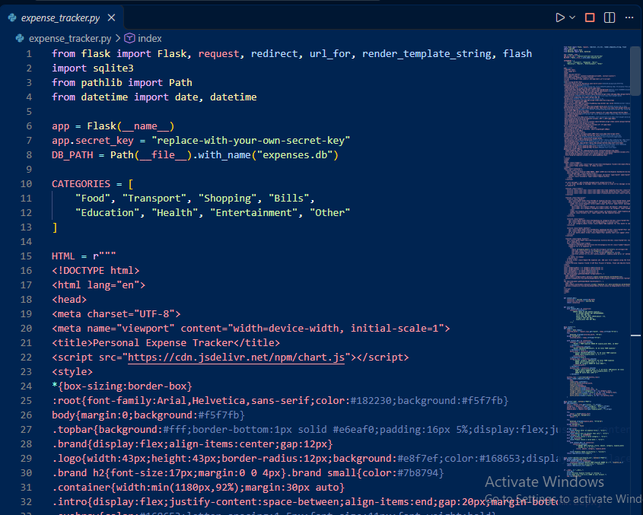

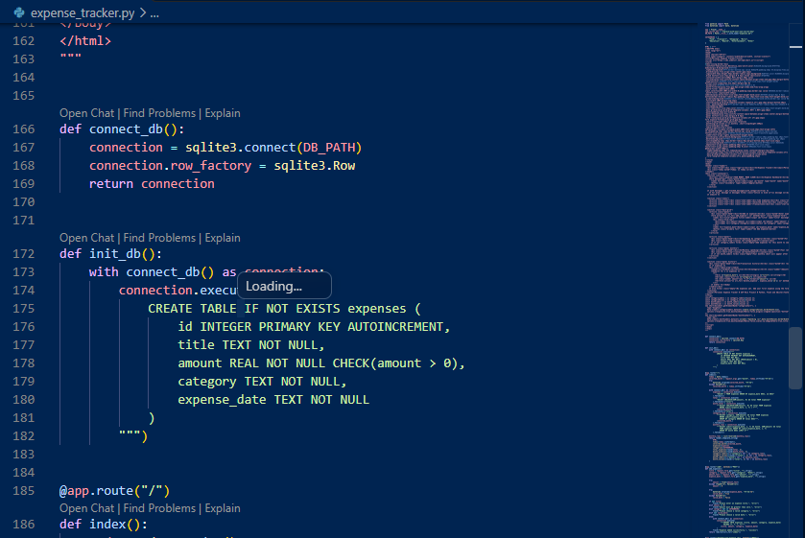

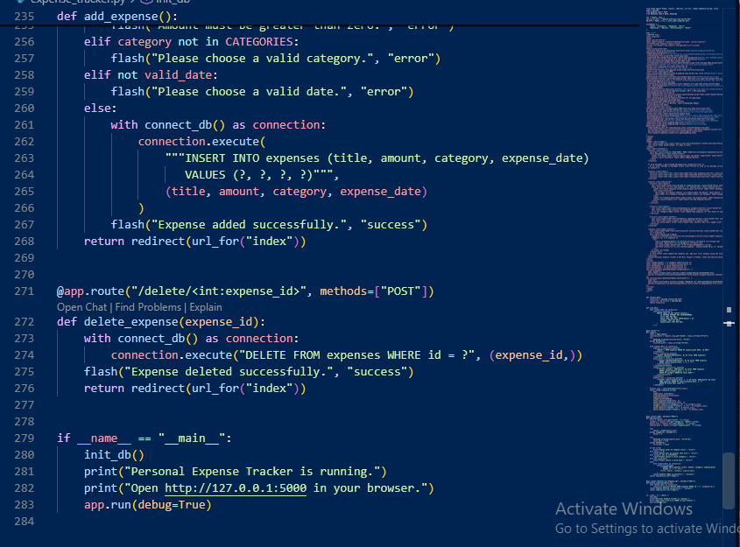

Output:

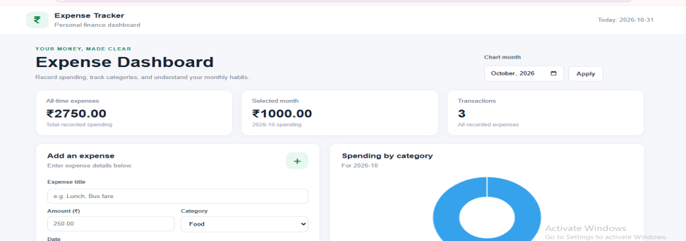

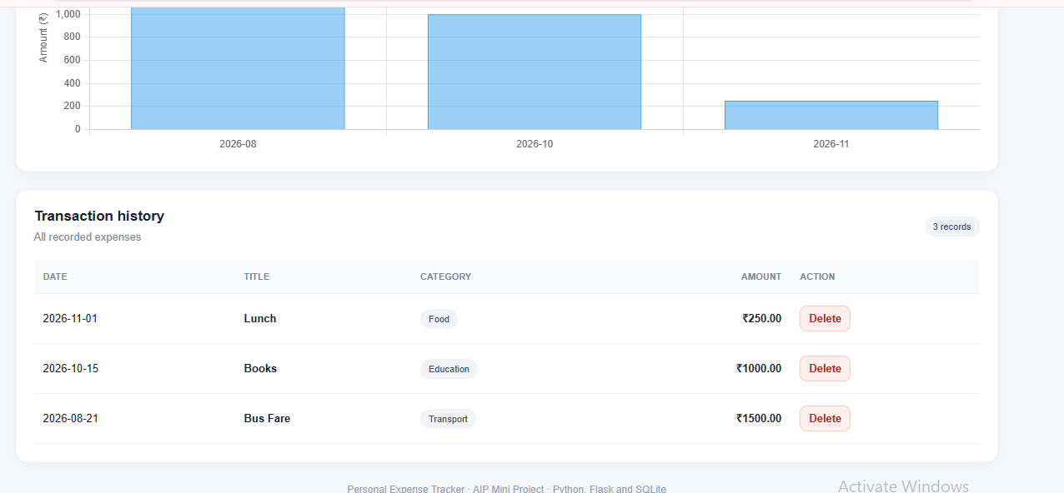

CHAPTER 6: FUNCTIONALITIES OF PERSONAL EXPENSE TRACKER SITE

6.1 Introduction
The Personal Expense Tracker Site is designed to make personal financial management simple and easy. It provides different functionalities that help users record, manage, update, delete, and monitor their daily income and expenses. The website provides a simple dashboard where users can view their financial information in one place.

6.2 Main Functionalities of the Project
1. Dashboard
The dashboard is the main page of the website. It displays important financial information.
Features:
- Displays total income.
- Displays total expenses.
- Shows available balance.
- Provides an overview of transactions.
2. Add Income
This functionality allows users to enter their income details.
Features:
- Enter income title.
- Enter income amount.
- Select income category.
- Select transaction date.
- Save income details.
Example: Monthly Salary – ₹20,000.
3. Add Expenses
This functionality allows users to record their daily expenses.
Features:
- Enter expense title.
- Enter expense amount.
- Select expense category.
- Select transaction date.
- Save expense details.
Example: Food – ₹500.
4. View Transaction History
Users can view all previously added income and expense records.
Features:
- View transaction title.
- View transaction amount.
- View category.
- View transaction type.
- View transaction date.
5. Delete Transaction
This functionality allows users to remove unwanted transaction records.
Features:
- Select the delete option.
- Confirm the deletion.
- Remove the selected record from the database.
- Update the dashboard totals.
6. Automatic Balance Calculation
The system automatically calculates the available balance using total income and total expenses.
Formula:
\[ \text{Balance} = \text{Total Income} - \text{Total Expenses} \]
Example:
Description | Amount
Total Income | ₹20,000
Total Expenses | ₹3,000
Available Balance | ₹17,000
7. Expense Categorization
Users can organize their expenses into different categories.
Category | Example
Food | Grocery and restaurants
Shopping | Clothes and accessories
Travel | Bus and taxi
Education | Books and fees
Bills | Electricity and mobile
Other | Miscellaneous expenses
8. Database Management
The system uses SQLite to store transaction information.
Features:
- Store transaction records.
- Maintain transaction history.
- Retrieve financial information.
- Delete unwanted records.
- Maintain data between application restarts.

6.3 Main Modules of the Project
The project is divided into the following modules:
Module | Description
Dashboard Module | Displays financial summary
Income Module | Manages income records
Expense Module | Manages expense records
Transaction Module | Displays transaction history
Calculation Module | Calculates income, expenses and balance
Database Module | Stores and retrieves records

6.4 User Interface
The website provides a simple and user-friendly interface.
The main interface contains:
- Website heading.
- Financial summary cards.
- Add transaction form.
- Category selection.
- Transaction history table.
- Delete transaction option.

6.5 Security and Data Management
The project uses basic database and input-handling practices to manage transaction information.
- Uses parameterized SQL queries.
- Validates transaction amounts.
- Stores information in an SQLite database.
- Prevents invalid transaction types.
- Maintains stored records after restarting the application.
Note: The current project is a basic single-user application and does not include login authentication or advanced security features.

6.6 Benefits of the Project
- Easy management of daily expenses.
- Saves time and effort.
- Reduces manual calculations.
- Helps users manage their budgets.
- Maintains transaction history.
- Provides automatic balance calculation.
- Improves financial awareness.
- Simple and easy-to-understand interface.

6.7 Limitations of the Project
The current version has some limitations:
- No user login and registration system.
- No online payment integration.
- No automatic bank account connection.
- No advanced graphical reports.
- No AI-based expense prediction.
- Designed mainly for basic personal expense management.

6.8 Conclusion
This chapter explains the main functionalities and modules of the Personal Expense Tracker Site. The application provides features such as adding income, recording expenses, viewing transaction history, deleting records, categorizing expenses, and calculating the available balance. These functionalities make the website a useful and simple solution for managing personal financial records.

CHAPTER 7: CONCLUSION, FUTURE SCOPE AND LEARNING OUTCOMES

7.1 Introduction
This chapter explains the overall conclusion of the Personal Expense Tracker Site, its future improvements, and the knowledge gained during the development of the project. The project is developed using Python, Flask, HTML, CSS, JavaScript, and SQLite. It provides a simple platform for recording, managing, and tracking personal income and expenses.

7.2 Conclusion
The Personal Expense Tracker Site is a useful web-based application developed to make personal financial management easier and more efficient. The main purpose of this project is to help users maintain their daily financial records in one place. The application provides several useful features, such as:
- Adding income and expense records.
- Viewing transaction history.
- Deleting unwanted transactions.
- Calculating total income automatically.
- Calculating total expenses automatically.
- Displaying the available balance.
- Managing expenses through different categories.
This project helped me understand how frontend, backend, and database technologies work together to develop a complete web application. Overall, the project provides a simple and effective solution for basic personal expense management.

7.3 Future Scope
The Personal Expense Tracker Site can be improved in the future by adding more advanced features.
1. User Login and Registration
A login and registration system can be added to allow multiple users to maintain their personal financial records separately.
2. AI-Based Expense Prediction
Artificial Intelligence can be integrated to analyze previous spending patterns and predict future expenses.
3. Graphical Reports
Charts and graphs can be added to display monthly expenses, income, and spending categories.
4. Monthly Budget Management
Users can set monthly budgets and receive alerts when their spending approaches the budget limit.
5. Mobile Application
The website can be converted into a mobile application so users can manage their expenses anywhere.
6. Automatic Expense Notifications
Notifications can be added to remind users about expenses and monthly budget limits.
7. Cloud Database
Cloud database technology can be integrated to store financial information securely and access it from different devices.
8. PDF and Excel Reports
Users can download their monthly income and expense reports in PDF or Excel format.

7.4 Learning Outcomes
During the development of this project, I learned several important concepts and practical skills.
- Python Programming: Learned how to write and execute Python programs.
- HTML: Learned how to create website structures and forms.
- CSS: Learned how to design attractive and responsive web pages.
- JavaScript: Learned how to add interactive features.
- Flask Framework: Learned how to develop a web application using Python.
- SQLite Database: Learned how to store and retrieve financial records.
- Frontend Development: Understood how to design user interfaces.
- Backend Development: Learned how to process user requests and perform calculations.
- Database Connectivity: Understood how the application communicates with a database.
- Project Development: Gained practical experience in developing a complete web application.

7.5 Applications of the Project
The Personal Expense Tracker Site can be useful for:
- College students managing their monthly expenses.
- Working professionals tracking their salaries and spending.
- Families managing household budgets.
- Individuals monitoring daily transactions.
- Small personal financial record management.

7.6 Overall Project Summary
Particulars | Details
Project Name | Personal Expense Tracker Site
Frontend | HTML, CSS, JavaScript
Backend | Python, Flask
Database | SQLite
Application Type | Web-Based Application
Main Purpose | Personal Expense Management
Main Features | Income, Expenses, Balance, Transactions

7.7 Final Conclusion
The Personal Expense Tracker Site successfully demonstrates how a simple web application can help users manage their personal finances. It reduces the effort required for manual calculations and provides an organized way to maintain financial records. Through this project, I gained practical knowledge of web development, Python programming, database management, and application development. In the future, this project can be upgraded with Artificial Intelligence, graphical analysis, budget alerts, and mobile application support to make it more powerful and useful.

